Pratham U-210905407

Computer Networks Lab 8:STUDY OF DHCP PROTOCOL

LAB EXERCISES
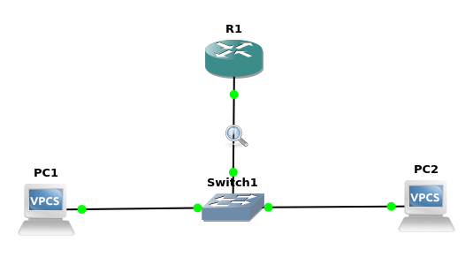

R1(config)#IP dhcp pool NAME
R1(dhcp-config)#Network 192.168.3.0 255.255.255.0
R1(dhcp-config)#Default-router 192.168.3.1

R1(config)#Interface fastEthernet 0/0
R1(config-if)#No shutdown
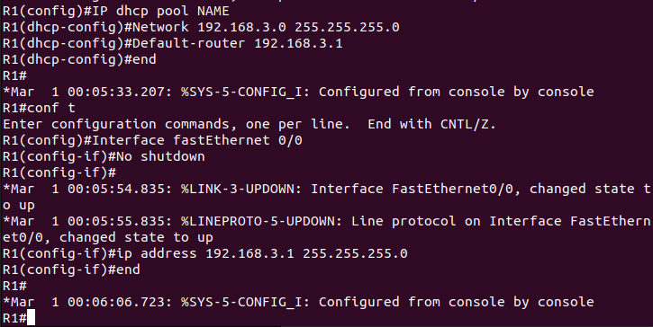
R1(config-if)#ip address 192.168.3.1 255.255.255.0
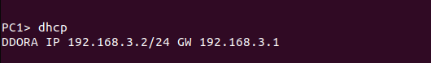

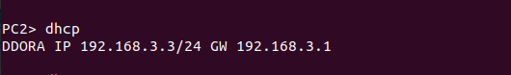

2. Network Prefixes and Routing

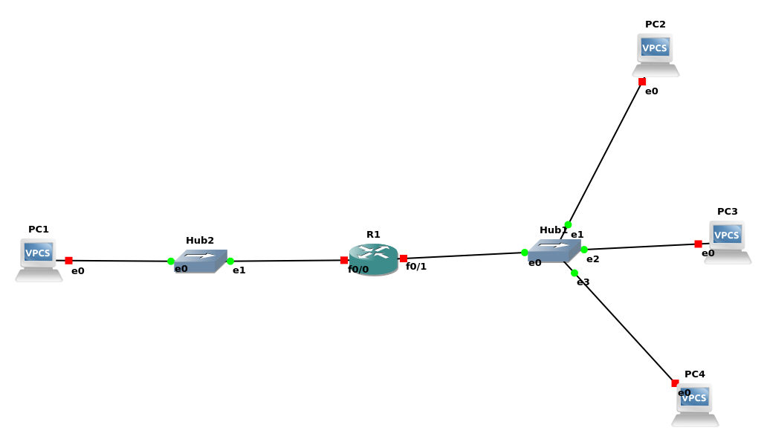

a. Configure the hosts and the router to conform to the topology shown in Figure 8.2, using the
IP addresses as given in Table 9.1. Note that PC2, PC3, and PC4 have different netmasks.

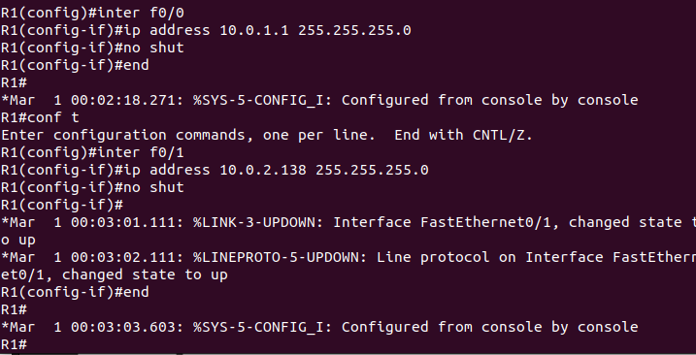
b. Add Router1 as default gateway on all hosts. (PC1, PC2, PC3, and PC4).

